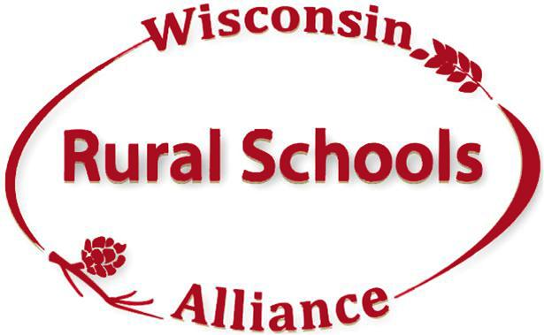

**President, Chuck Keller**

**President-Elect, Cheryl Gullicksrud**

**Secretary, Diana Bohman,**

**Treasurer, Robert Smudde**

**Past President, Ben Niehaus**

**Kim Kaukl**

**Executive Director**

**1755 Oakwood Circle**

**Plain, WI 53577**

**Cell Phone: (608) 553-0689**

**kimkaukl@wirsa.org**

February 17, 2020

To: Joint Finance Committee

Good morning Representative Nygren, Senator Darling and all members of the JFC,

On behalf of the Wisconsin Rural Schools Alliance (WiRSA) I ask that you take the time to review Governor Evers’ proposal of a comprehensive plan on how to invest the state surplus funds into our public schools. In reviewing his proposal, you will see how it clearly aligns with many bi-partisan initiatives on education already being discussed. This proposal will advance educational opportunities for all Wisconsin public school children. It will expand access to mental health services, invest in special education for our students with disabilities, renew the state’s commitment to two-thirds state funding of public schools and invest in rural schools through increased sparsity aid. We believe this proposal is a win for both our students and our taxpayers as it increases needed resources for all students AND reduces property taxes. It is also our belief that the additional dollars allocated to education will lessen the need for many schools to go to their taxpayers for operational referendums, thus providing more tax relief for property owners.

In conclusion, WiRSA not only supports this plan for rural students, but for all students in Wisconsin. We hope you will look closely at how this plan can move forward many bi-partisan education goals along with providing property tax relief. We also encourage all legislators to meet with their local school/community leaders, taxpayers, teachers and school boards to see how this proposal will positively impact all children and the community before voting on this.

By supporting this proposal, you are making an investment in all students and strengthening the development our state’s future workforce.

Thank you for your consideration,

Kim Kaukl

Kim Kaukl  
Executive Director

Wisconsin Rural Schools Alliance

608-553-0689

[kimkaukl@wirsa.org](mailto:kimkaukl@wirsa.org)

*The Wisconsin Rural Schools Alliance (WiRSA) was formed to help rural school districts address the unique issues that affect rural schools as they strive to achieve the highest quality education for every student. Our organization represents and supports over 220 members with 158 rural school (districts administrators, teachers and school board members), several CESAs, technical colleges, universities, businesses and individual members. Wisconsin rural schools are home to 77% of the public-school districts in the state.*

*Strong Schools, Strong Communities*